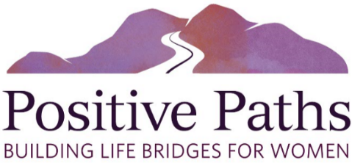
2024 Positive Paths Man and Woman of the Year
OUR MISSION
Positive Paths exists to support East Valley women in need by providing a life-bridge to economic stability, personal growth and professional achievement. We do this through scholarship and mentoring programs, and supportive services. We encourage others to invest in the future of East Valley women in need, and to support East Valley women to be resilient and positive contributors to their communities.
Our annual Night of Heroes Gala will recognize one female and one male
who have significantly contributed to helping women in the East Valley.

Name of nominee:
Check one: Positive Paths Man of the Year Positive Paths Woman of the Year
Please confirm this person’s residence or business is located in the East Valley: Yes/Confirmed
Company/Organization:
Address:
Email: Phone:

Please describe in 500 words or less how this person has significantly contributed to helping women in the East Valley. Submit this cover sheet with your description via email. Resume, biography or other supporting documentation is also appreciated. Please ensure your nomination clearly describes how your nominee meets one or more of these criteria:
- Demonstrated outstanding leadership and vision
- Introduced new and innovative ways to assist women
- Committed significant volunteer time to a cause that supports women
- Provided significant monetary investment to Positive Paths or another cause that supports women
- Served as a spokesperson for helping women
- Instituted policy change through advocacy
- Created collaborative partnerships to accomplish goals

Nominated by:
Email: Phone:

Nominations (inclusive of this cover sheet and the description addressing the criteria)
must be received no later than November 15, 2023. Email nominations to info@positivepathsaz.org.
For more information or if you have any questions, please call 480-788-0615.

