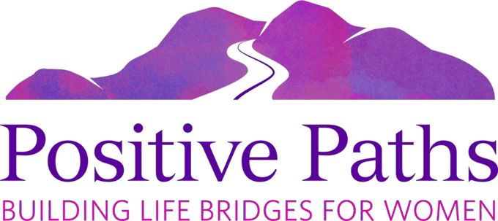

“Play for Paths”

Join host and emcee Ray Adams at our
4th Annual Golf and Luncheon Fundraiser

Sunday, November 19, 2023

Red Mountain Ranch Country Club
6425 E. TETON CIRCLE, MESA, AZ 85215
Check-in: 7am to 8am
(Please arrive early)
Shotgun Start: 8am

To Register:
positivepathsaz.org/golf-event/

Join us for a fun foursome scramble with exciting side games! Event host and emcee Ray Adams is a popular broadcast personality who hosts two long-time golf radio shows here in the Valley, as well as his Match Play TV show.

Donation:
$175 Per Golfer
$700 Foursome
INCLUDES:
BBQ lunch, green fees, cart, driving range & putting green usage, as well as great giveaways!

Prizes:
1st Place Team
2nd Place Team
3rd Place Team
Most Honest (Last Place Team)

Sponsors:
Corporate Air Mechanical Services (CAMS)
TrustBank
McColes Ranch
First International Bank and Trust

POSITIVE PATHS
is a nonprofit organization that serves East Valley women through scholarship and mentoring programs.

FOR MORE INFORMATION:
480-788-0615

